Team 11
Riley Anderson, Aiden Burke, Ryland Edwards, Riley Meyerkorth, Hannah Smith, Colin Treanor

Initial Architecture: polypod

Project Synopsis
The polypod is a desktop productivity device with near real-time notifications, attention and emotion detection, and a user-shaped personality.

Software Overview
(3-5 graphs, no more than 1,000-1500 words of narrative)
Polypod’s software can be broken down into three major pieces. The frontend (coined ‘polywork’, which allows users to use a web app to configure their device), the server (which is responsible for storing user profiles, calling upon and storing data from 3rd party APIs, and communicating with the physical device), and the device itself (which will parse configuration and notification data from the server into notifications, along with some built-in productivity features). The beginning of a 3D model can be seen in fig. 1. A 2D drawing of the finished project can be seen in fig. 2. Additionally, the pinout diagram explains how the handwear will work together, see fig. 3. The way in which these software components will be structured can be seen in the UML diagram see fig. 5. How the user and other external sources interact with the polypod and polywork see fig. 4.

The way in which the user and other external sources interact with our system

Individual Software Component Implementation

Frontend
The frontend consists of a web app (optimized for mobile devices) built with Native React and TypeScript. It will capture the user's intended configuration but will not perform any logic on the physical device, communicating only with the server.

Server / Database
The server will be built using TypeScript, and use Express for routing. The server acts as the bridge between the client and the physical polypod. The server will store preferences set by the user, query external resources, and relay information to the device.

Device
The device will leverage TypeScript to maintain a persistent connection to the server to receive notification and configuration payloads. The on-device GUI will be created using flutter-pi, an extension of flutter. Background logic such as parsing notification/configuration data and vision-based emotion and object detection will be handled using a combination of TypeScript, and Python’s Torch library.

3D Modeling (fig. 1)

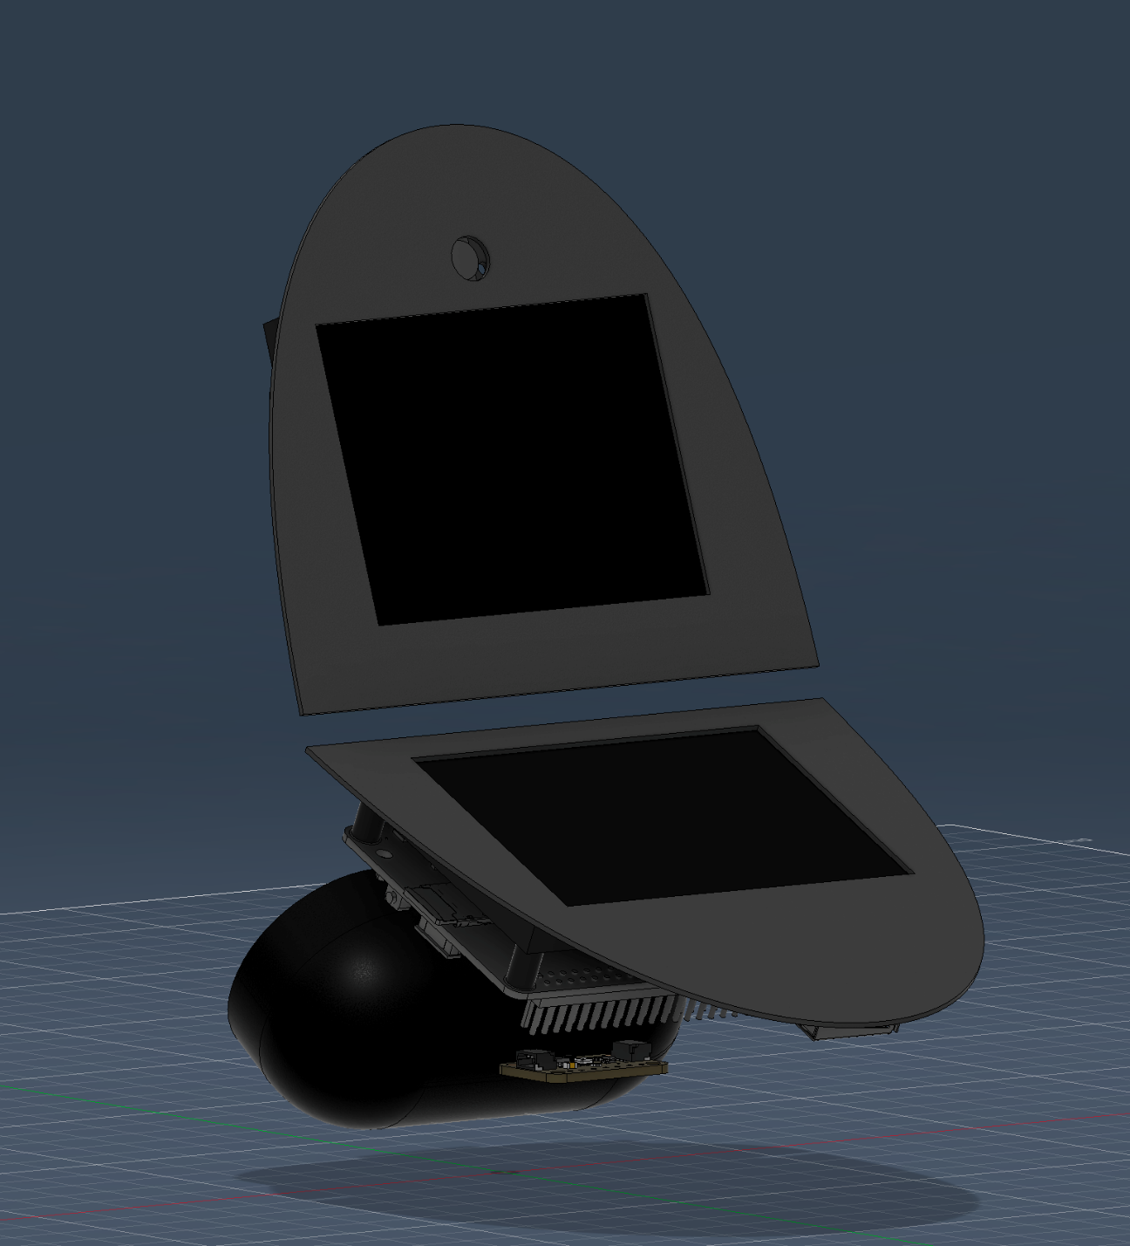
Current initial design of major components. Top section features a square display for a better fit to the case with the camera above it. Bottom section contains a touchscreen 3.5in display that interfaces with the raspberry pi from the back to not interfere with gpio pins to be used for other functions. Under the bottom screen will contain the environmental sensor, speaker, and excess cabling. The top screen will be able to be folded down to the top screen as the main way of turning off and on the Polypod. The back will articulate with scales that appear like an isopod.

Polypod Initial Drawing (fig. 2)

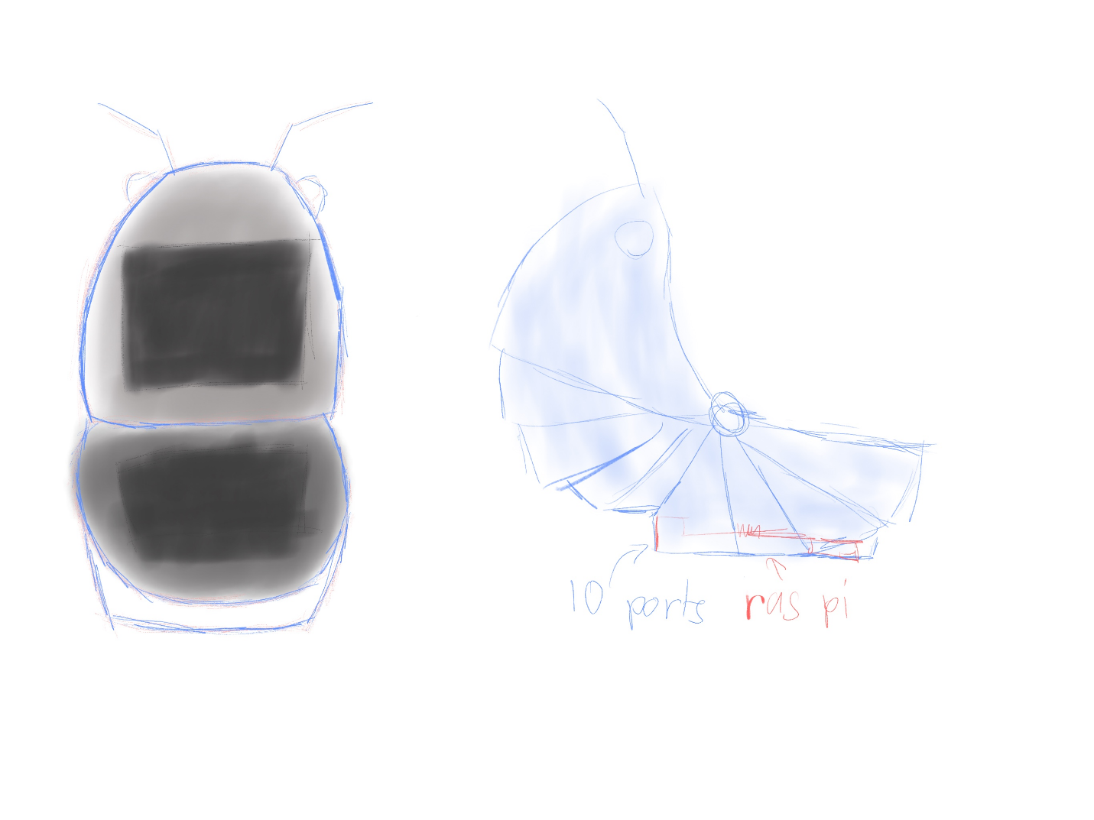
This drawing shows what a final version of the product would look like with the two-screen incased in an isopod looking shell with eyes that stick out as well as antenna. It shows that the raspberry pi and other hardware would be inside the base on the 3D printed shell and that there is a pivot in the middle so that you can open and close the case. When the case is closed the device goes into low power mode.

Pin Out Diagram (fig. 3)
The hardware for the polypod consists of a few major components:
- A Raspberry Pi 5 for computation
- A 3.5in resistive touch display for the bottom screen
  - This display does not connect to the board in the same way as the other connections. It is attached to the bottom of the board, with connectors being attached to the bottom of the GPIO pins. This leaves many necessary pins open for us to use.
- A 3.5in DSI capacitive touch display for the top display
- A USB 2.0 speaker for outputting sound and notifications
- A DSI camera module for the polypod to see its surroundings
- A BME680 multi-sensor module for measuring environmental pressure, humidity, temperature, and gas
  - Additionally, we utilize a QWIIC Shim attachment to connect the BME680 module instead of the pins. This helps consolidate the GPIO pins.
- 2 RGB cathode LEDs for the eyes of the polypod
  - Additionally, we utilize a custom module for the RGB connections, ground, and resistors. This comes with many benefits, including a consolidation of GPIO/ground pins, the centralization of connections, and the ability to control both LEDs simultaneously without any extra computation.

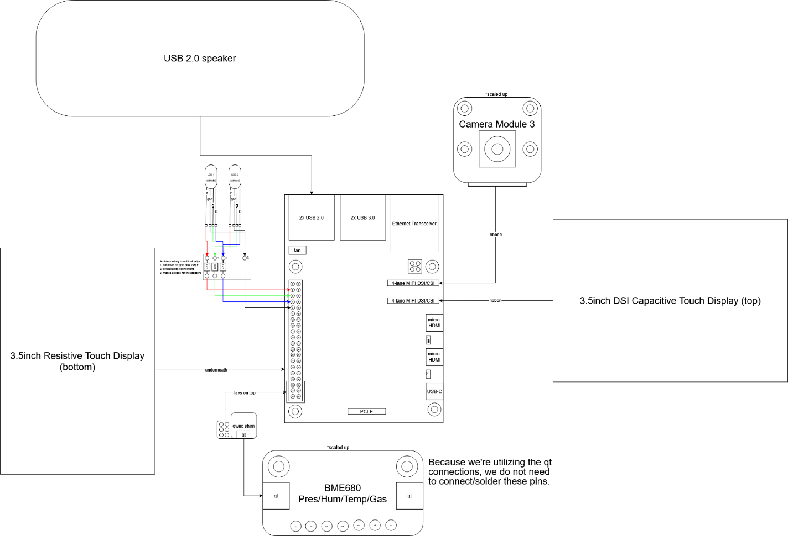

Logical Data Flow Diagram (fig. 4)
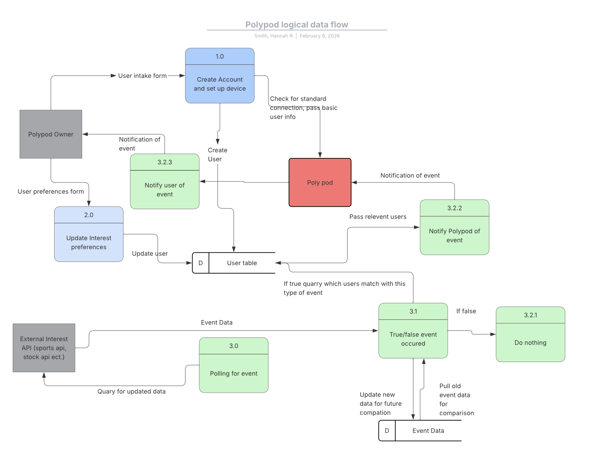
This diagram shows how a polypod user would interact with polywork, the physical polypod, and how an external API would also interact with the system. In this diagram, there are three main processes. One where a new user connects to their polypod and gives basic preferences about what types of notifications they would receive. This creates records on the user's database. A second process where the user is able to upload changes to these preferences. This would update the user database record without sending any additional information to the polypod. The final process involves polling an external API to look for events that would require a polypod notification. The event database would allow us to compare previous event data and determine if an event has occurred. This would require updating an event database with relevant information. If an event has occurred, then the relevant users will be pulled from the database and then a notification sent to their polypod. The poly would then alert the user.

UML Class Diagram (fig. 5)
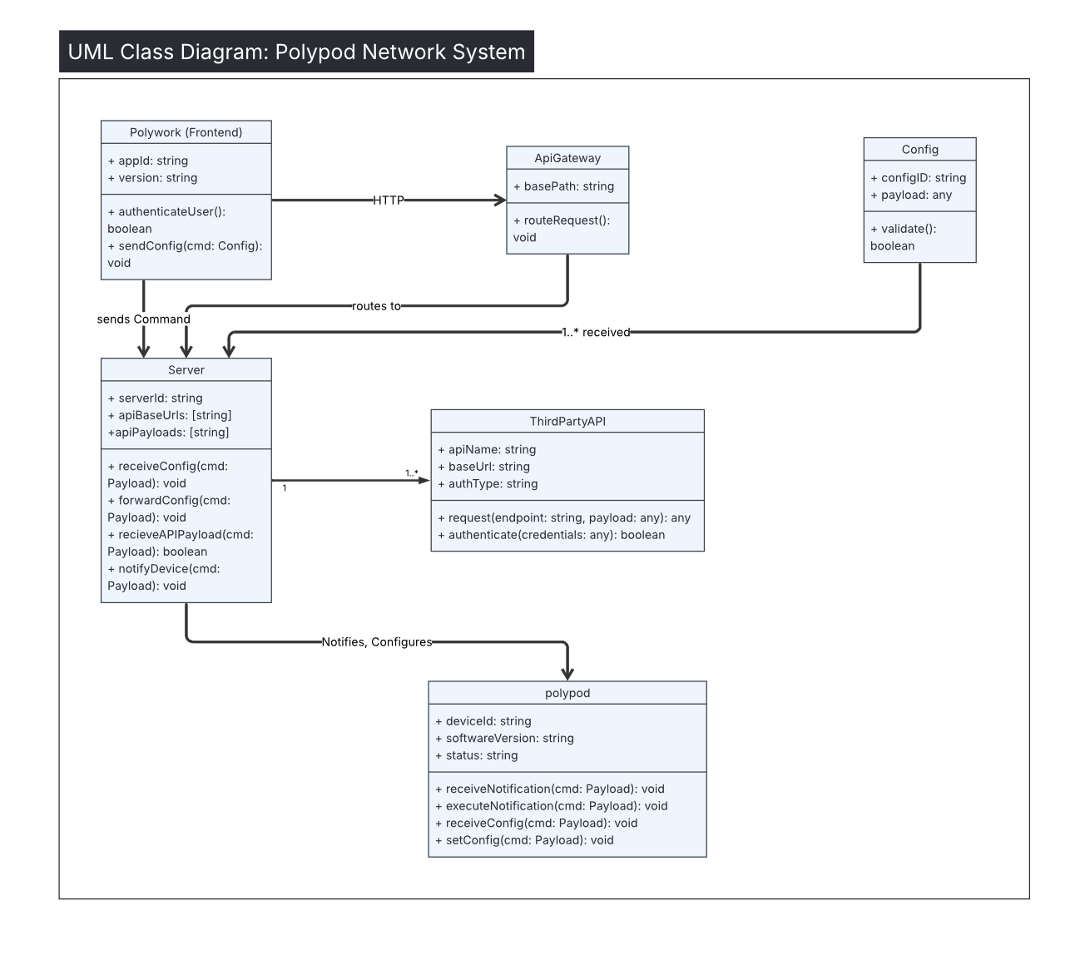The above diagram showcases how the different major components interact with one another to form the polypod ecosystem and the specific functions which facilitate that communication. The config class is a data structure that holds the payload which will be used as the communication device between each of the different pathways. In communications between the frontend and server, the config class is used to pack data and then parse it to be stored. The server is also able to send data packed in the config class to be parsed on the physical device. This parsed information can either be a new configuration style (either a color scheme, enabling or disabling the camera, etc.) or a a new notification (such as a touchdown in a football game, a stock’s value increasing by a certain threshold, etc.). The ConfigID will contain both a number that will indicate if this is a duplicate message, and the message type if being conveyed to the polypod physical device.

